Baseline (Logistic Regression)

In Model 1, Logistic Regression is used as a baseline method. This model utilizes only the original input features without considering any interaction or correlation between them. Each feature contributes independently to the prediction. This approach represents traditional factor-based methods commonly used in landslide risk prediction. The performance of this model serves as a reference point to evaluate the effectiveness of more advanced approaches.

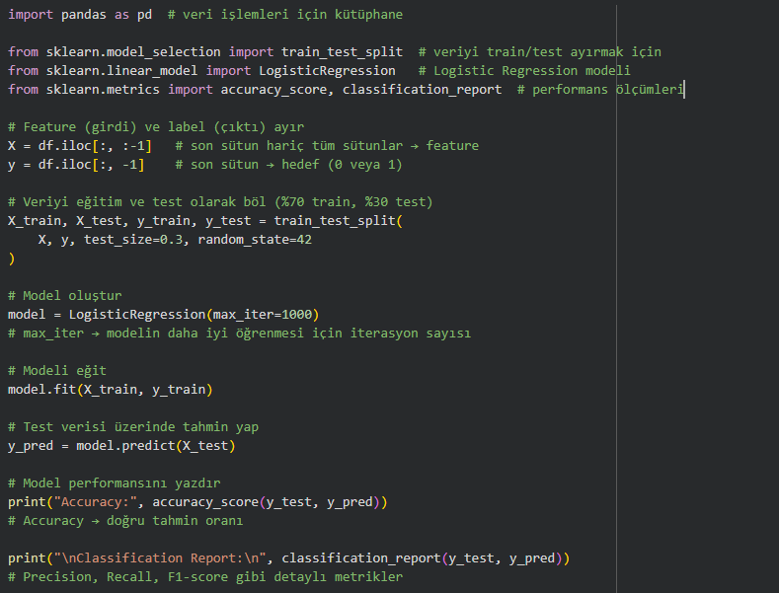

Result :
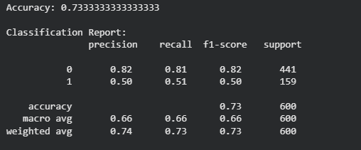

improved model (GBDT + Feature Interaction)

In Model 2, a Gradient Boosting Decision Tree (GBDT) model is applied along with feature interaction techniques to capture correlations between input variables. Polynomial feature expansion is used to generate interaction terms between features, allowing the model to learn complex relationships. This approach simulates the correlation-aware mechanism described in the knowledge graph-based method. As a result, the model is expected to achieve higher prediction performance compared to the baseline model.

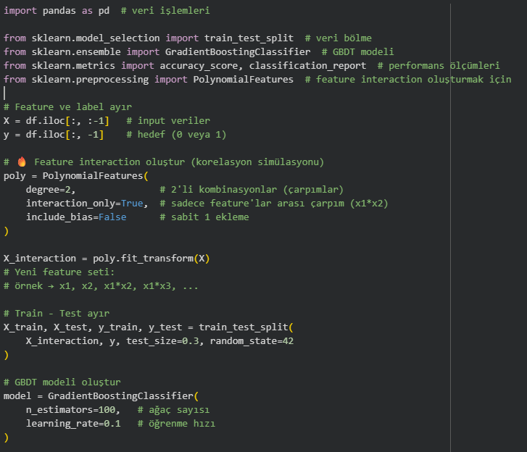
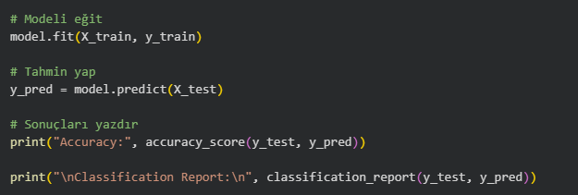

Result :
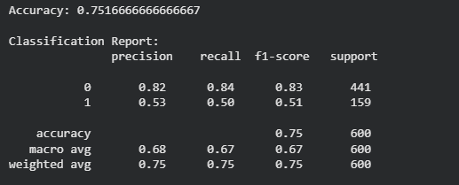

Comparison of Baseline and Improved Model
The experimental results demonstrate that the improved model outperforms the baseline method across most evaluation metrics. The overall accuracy increased from 73.3% in the baseline method to 75.2% in the improved model, indicating a clear enhancement in prediction performance.
In terms of precision, the improved model shows better reliability compared to the baseline method, meaning that its predictions are more accurate when identifying positive cases. Similarly, the F1-score, which reflects the balance between precision and recall, is also higher in the improved model, indicating a more stable and effective performance.
Although there is a slight variation in recall, the overall performance improvements suggest that the improved model is more capable of capturing meaningful patterns in the data. This improvement is mainly due to the incorporation of feature interactions, which allow the model to learn relationships between input variables rather than treating them independently.
Therefore, the results clearly demonstrate that using feature interaction (correlation) significantly improves the performance of the model compared to the baseline method. This confirms the importance of considering relationships between features in landslide risk prediction tasks.

Metric | Baseline Model | Improved Model | Fark
Accuracy | 0.733 | 0.752 | +0.019
Baseline Recall | 0.81 | 0.84 | +0.03
Improved Precision | 0.50 | 0.53 | +0.03
Weighted Avg Recall | 0.73 | 0.75 | +0.02

